1.Python program to find digital root of a number

Description:  
A digital root is the recursive sum of all the digits in a number. Given n, take the sum of the digits of n. If that value has more than one digit, continue reducing in this way until a single-digit number is produced. This is only applicable to the natural numbers.  
digit_root(0)= 0

digital_root(16)  
=> 1 + 6  
=> 7

digital_root(132189)  
=> 1 + 3 + 2 + 1 + 8 + 9  
=> 24 ...  
=> 2 + 4  
=> 6

def DigitalRoot(number):

addper = 0

while number >=10:

number = sum(int(digit)for digit in str(number))

addper +=1

print(number)

DigitalRoot(132189)

**Output:**

For : DigitalRoot(16)

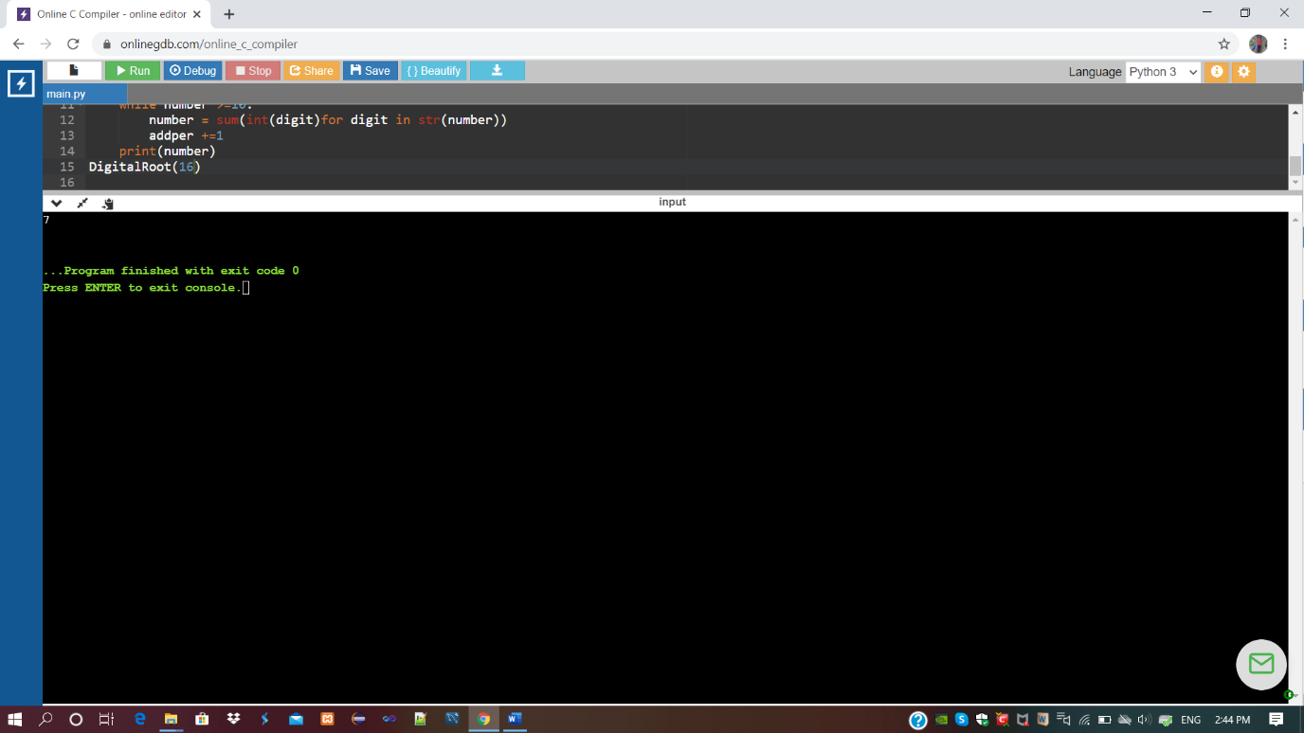

**Output:**

For : DigitalRoot(132189)

